Software Engineering 1 Assignment

C13569113 Andrew McCormack

DVD Database Rent/Reserve System

Problem Domain

* DVD Database systems, server’s, DVD’s, customer’s, administrators

Requirements

* To allow the user to log in and browse the selection of DVDs
* To allow the user to make a reservation
* To allow the user to rent a DVD
* To allow the user to extend their DVD rental
* To check the database for reserved copies when the user attempts to rent a DVD, not allowing the user to rent the dvd if there are no unreserved copies left.
* To check the database for unreserved copies when the user attempts to reserve a DVD, not allowing the user to reserve the dvd if there are no unreserved copies left.
* To check the database for unreserved copies when the user attempts to extend their DVD rental, not allowing the user to extend the rental if there are no unreserved copies left.

Screenshots Of Work

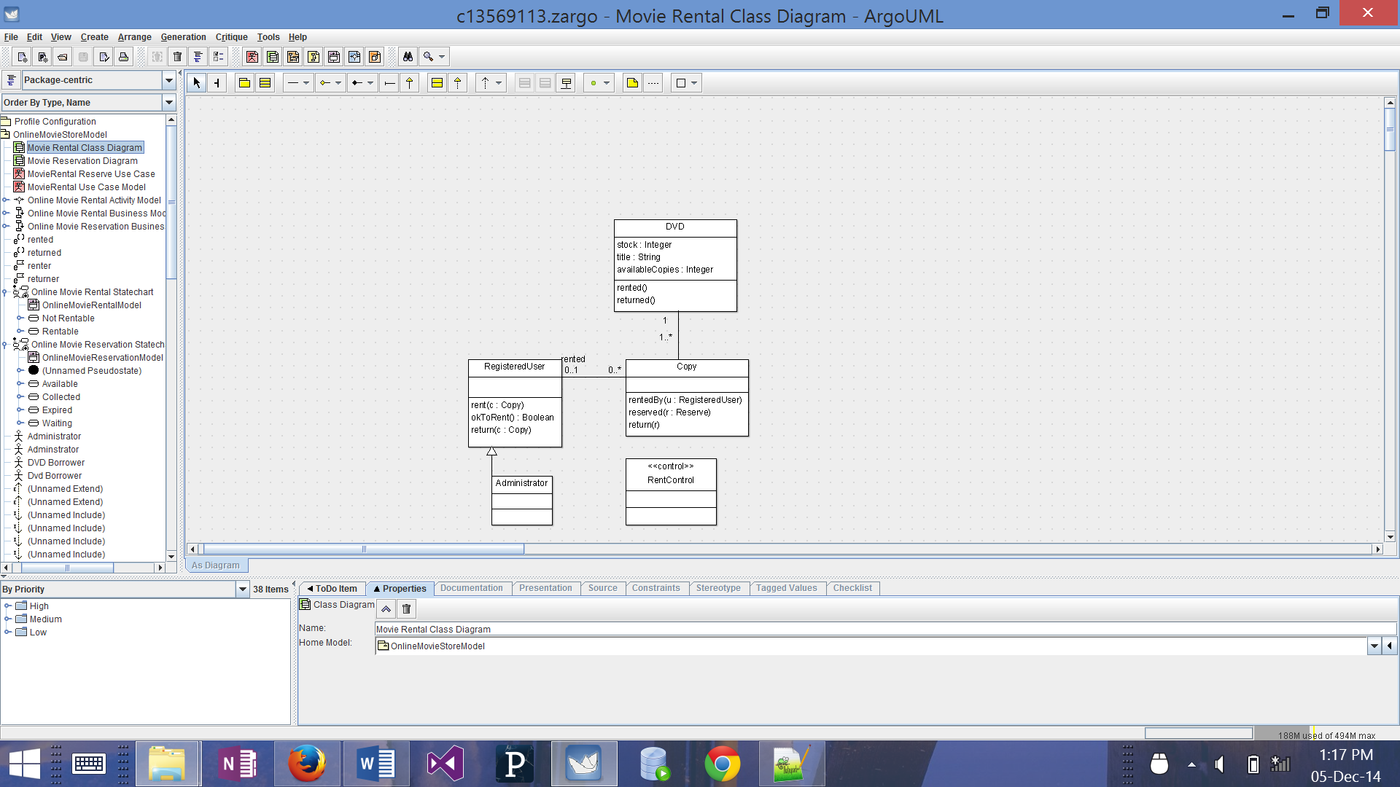

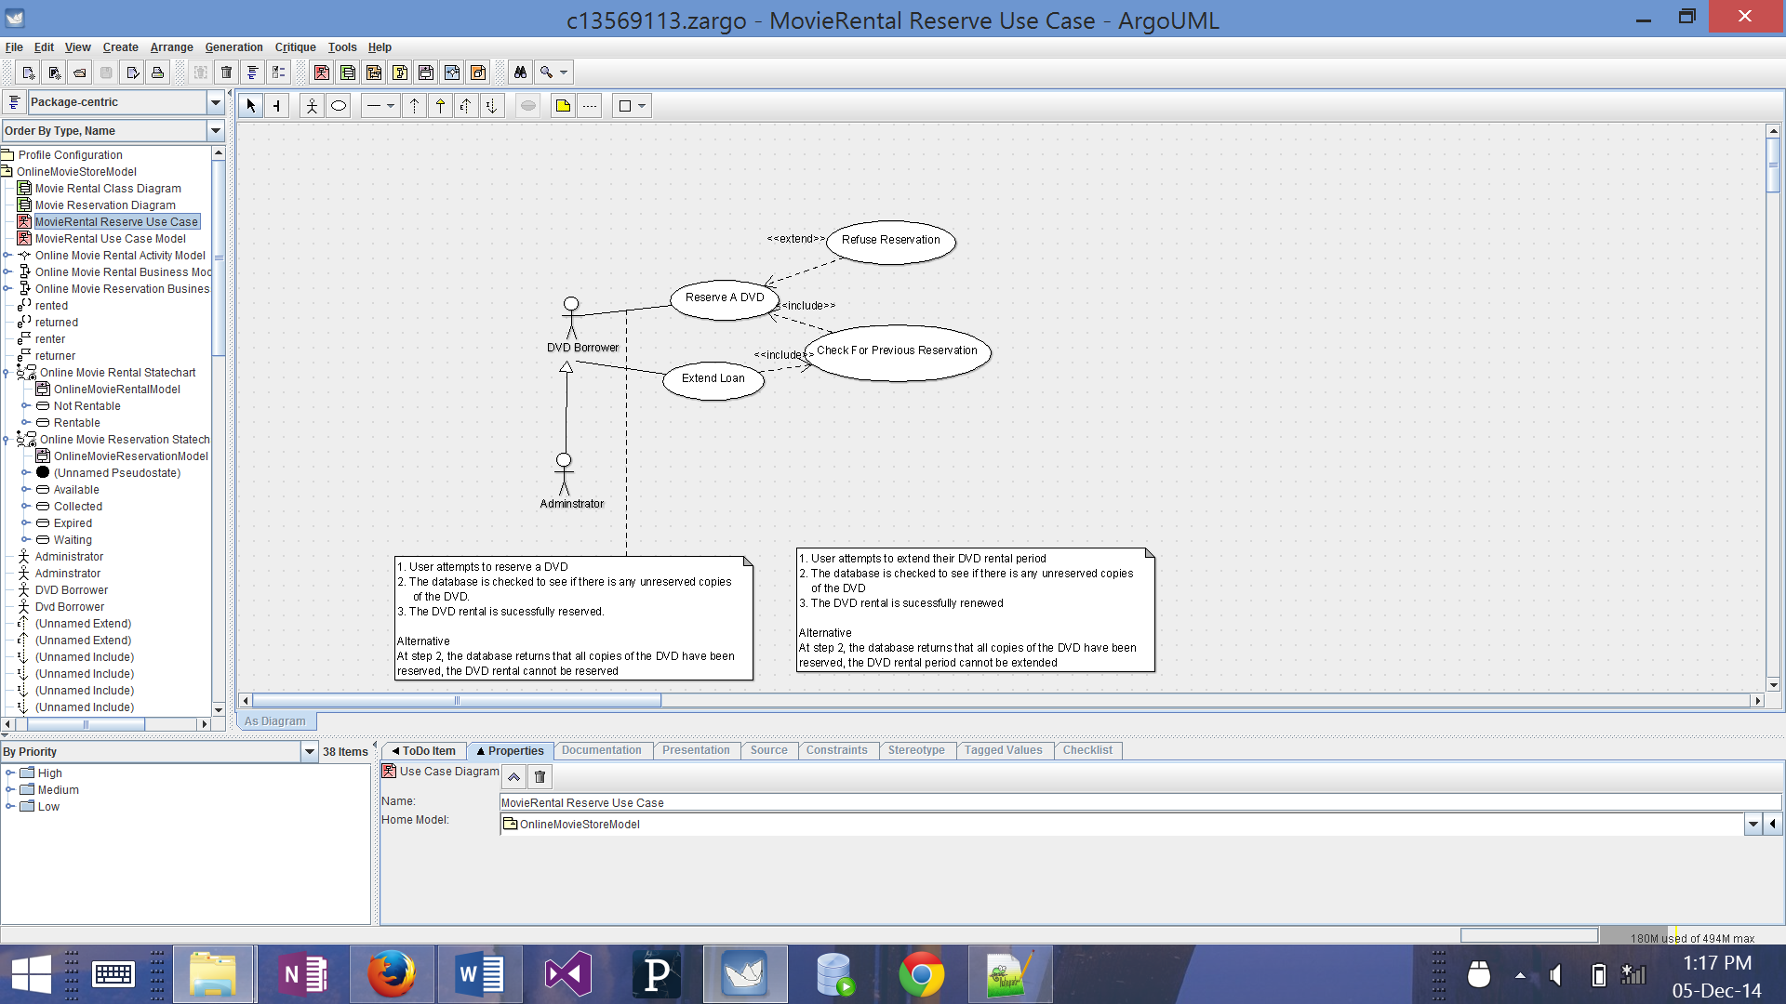

Rent A DVD Use Case

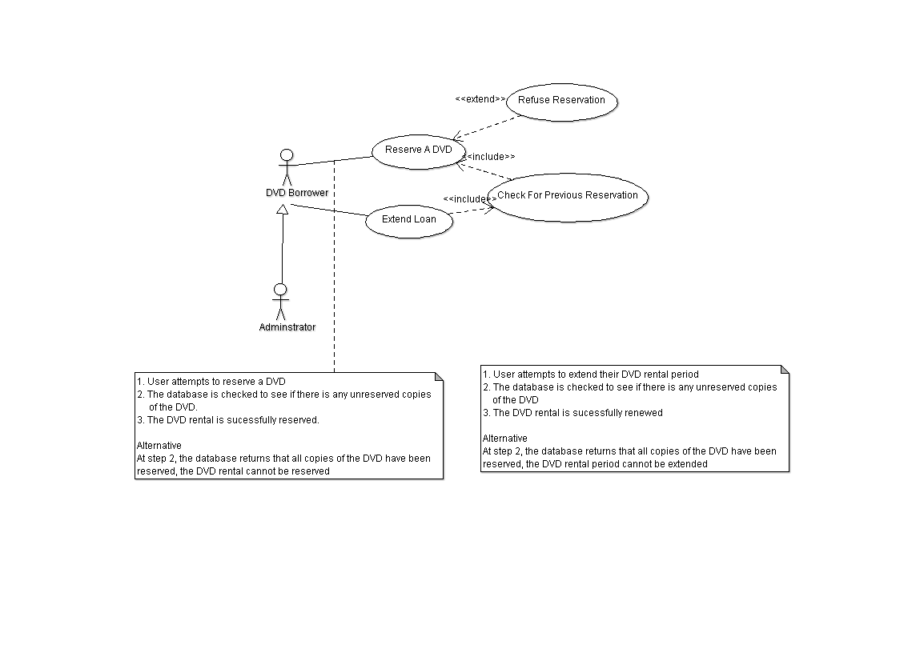

The use case contains comments for two possible scenarios, if the user attempts to rent a DVD and if the user attempts to extend their DVD rental. These scenarios also have one alternative for if the database returns that there are no unreserved copies of the DVD, in which cas the user’s request is denied

Reserve A DVD Use Case

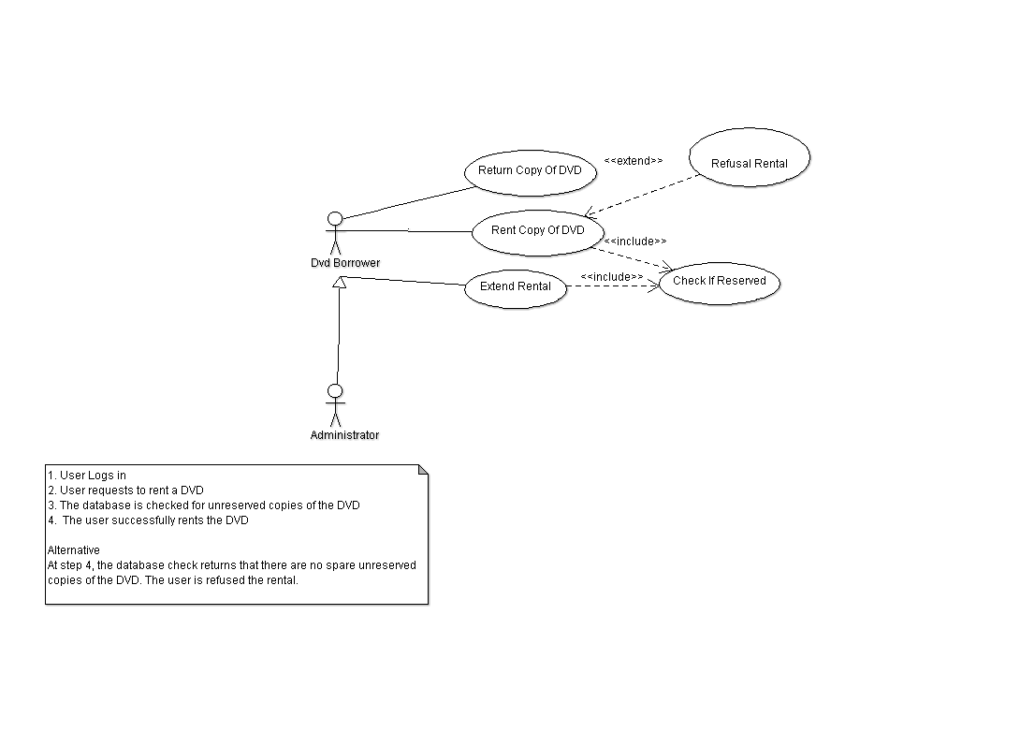

The use case contains a comment for the scenario that a user successfully reserves a DVD. In the alternative scenario, the user’s request to reserve the DVD is denied if the database returns that there are no unreserved copies.

Rent A DVD State Chart

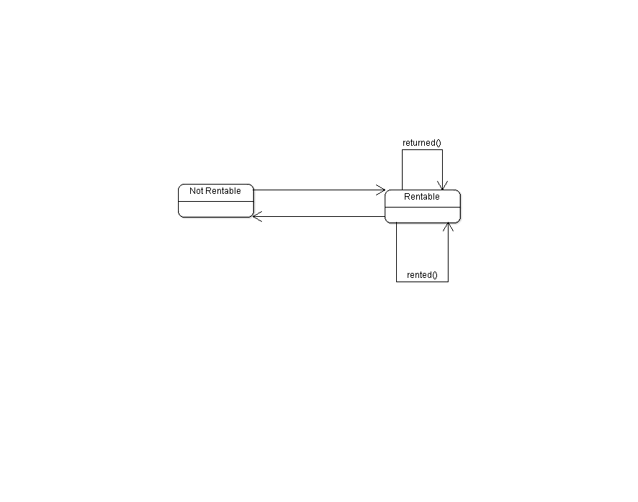

This state chart explains the relationship between DVDs that are rentable and one’s that are not. If the DVD has been returned, it becomes rentable again and vice versa.

DVD Reservation Statechart

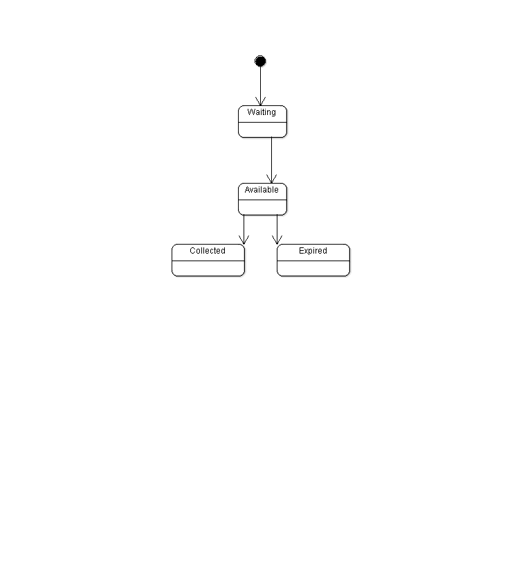

This state chart explains how the reservation system works, when the DVD becomes unreserved, it becomes available to reserve. When the DVD is reserved, the user must collect the DVD within a specified timeframe or else the reservation will expire.

Rent A DVD Class Diagram

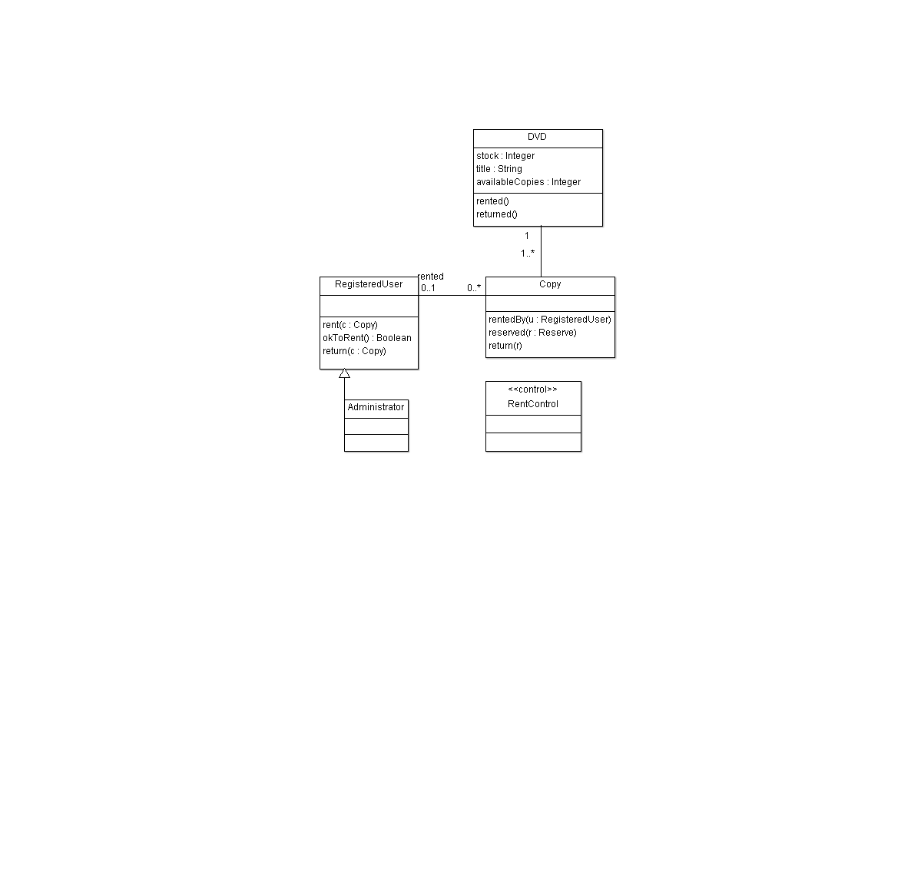

This class diagram contains the classes DVD, copy, registered user, administrator and rentControl as well as all the methods they contain

Reserve A DVD Class Diagram

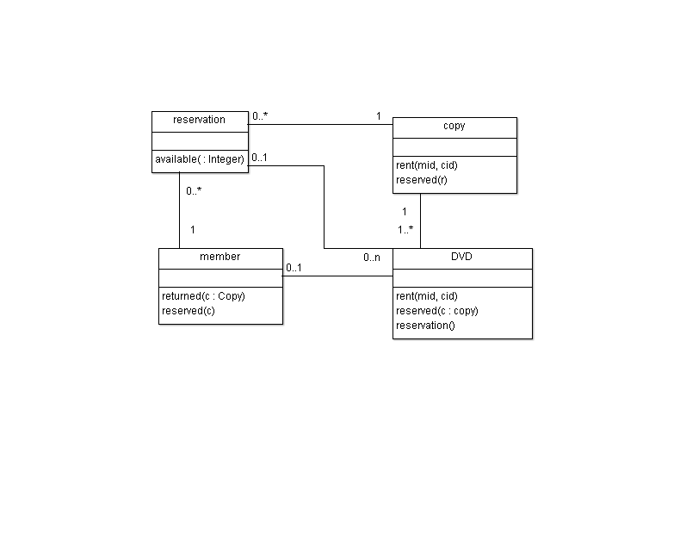

This class diagram contains the classes reservation, copy, member, DVD and all the methods they contain

DVD Rental Activity Diagram

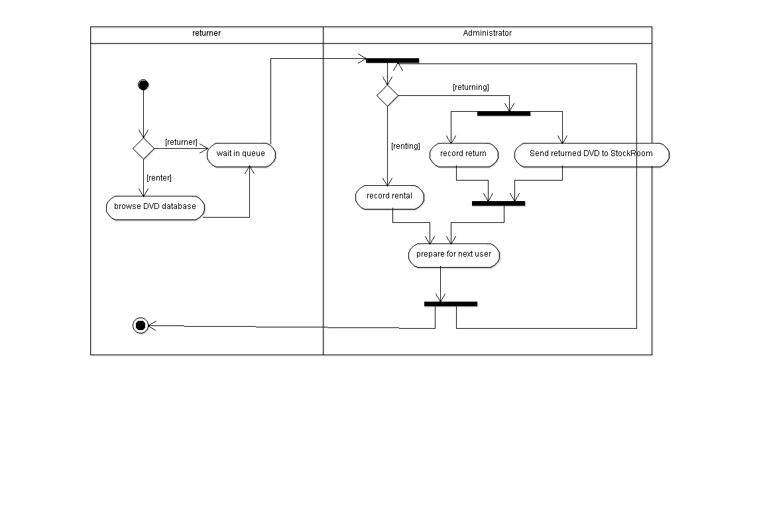

The activity diagram explains the relationship between the user and the administrator of the system, users must wait in a queue to allow the administrator to deal with each request individually.

Rent A DVD Sequence Diagram

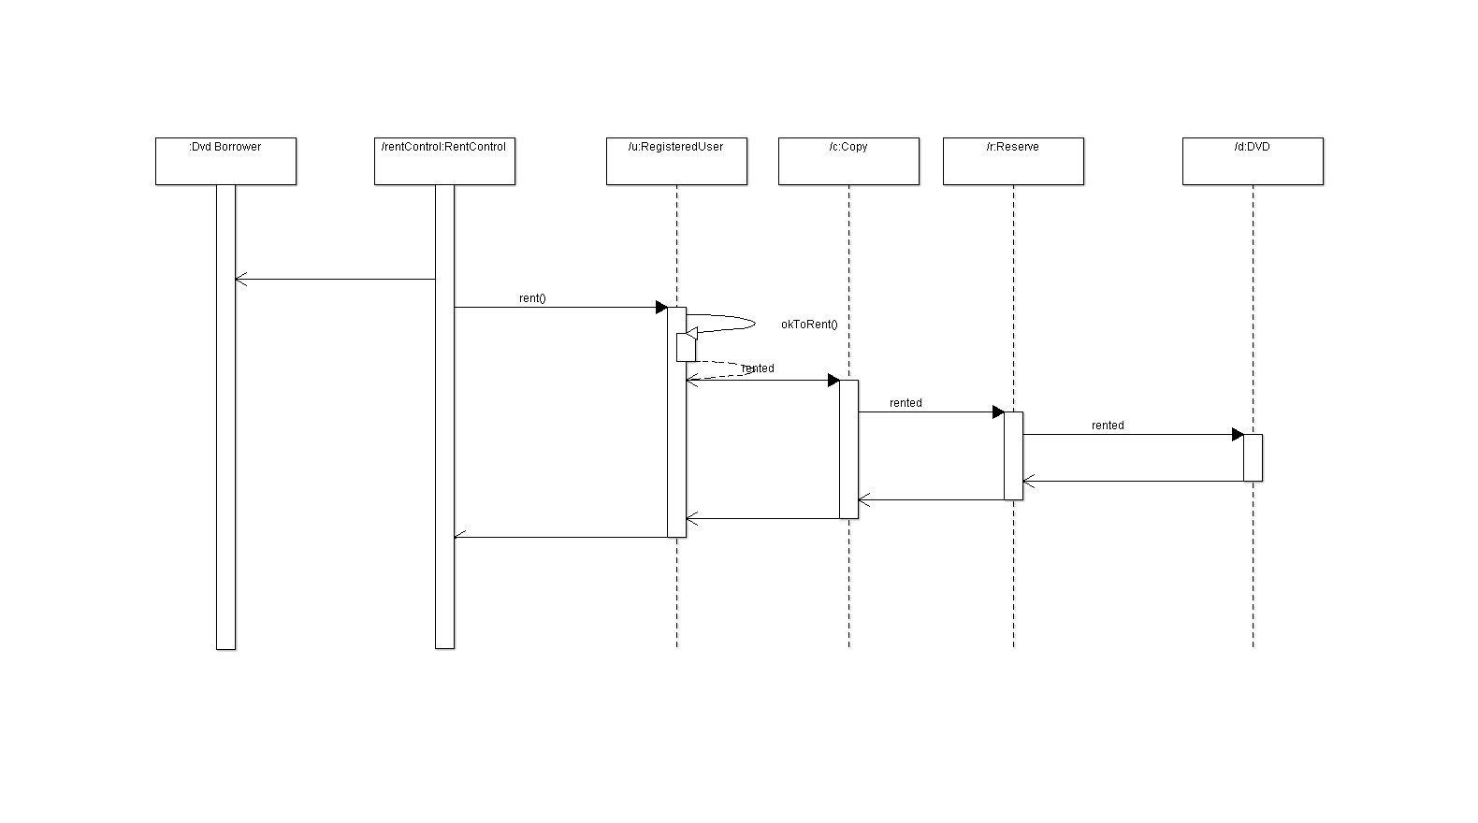

Reserve A DVD Sequence Diagram

